**Lab 1**

 Download the lab file [Lab1Start v5.xlsx](https://github.com/MicrosoftLearning/Introduction-to-Data-Analysis-using-Excel/raw/master/Module1/Lab1Start%20v5.xlsx) to answer the questions below.

1) The first thing you'd like to do is to present the data graphically. You do this by creating charts for the three groups of data you received from Jack, your IT manager. Give each chart a descriptive title as shown in the three charts below.

If you need a refresher on creating charts in Excel, review this [Microsoft Office Support article: Create a chart from start to finish](https://support.office.com/en-us/article/create-a-chart-from-start-to-finish-0baf399e-dd61-4e18-8a73-b3fd5d5680c2?ui=en-US&rs=en-US&ad=US)

Your first solution should look like this (numbers may not be the same). 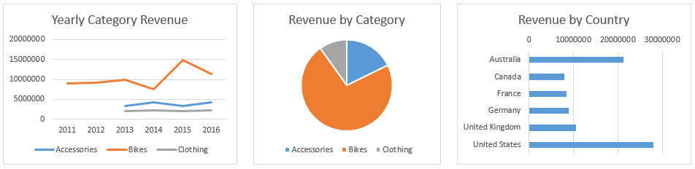

Once you have created the three charts above, let's customize them a little bit more.

For the **Yearly Category Revenue** chart, display the total revenue for each year as a separate line.

* 1. Create a Total Revenue line in the range C7 to H7 by summing the annual revenue in rows 3 through 6. Label the row as Total Revenue in cell B7
  2. Select the **Yearly Category Revenue** chart.
  3. The data source for the chart is highlighted.
  4. Drag the highlighted selection to include the total row (B7 to H7)

2)For the **Revenue by Category** chart, display the percentage for each category.

* 1. Select the **Revenue by Category** chart.
  2. From the Chart Tools **Design** tab, change the chart style to display the data as a percentage including the data label as percentages. You can do this by either selecting a style from the **Chart Styles** group (such as Style 8 in Excel 2016 for example) or from the **Chart Layouts** group by selecting one of the **Quick Layouts** (such as Style 6 in Excel 2016 for example).

3)For the **Revenue by Country** chart, sort the countries to display the one with the highest revenue showing at the top and the one with the lowest revenue at the bottom.

* 1. Select the data source for the **Revenue by Country** chart.
  2. Sort the data by **Revenue** from **Largest to Smallest** ensuring you also sort the countries with the revenue.
  3. Select the **Revenue by Country** chart.
  4. Select the Y axis, the axis that shows the country name.
  5. Select **Categories in reverse order** in the **Axis options**.